Perfusions: Rebecca General Notes
- Supplies
  - Isoflurane (under hood; flammable cabinet)
  - Jar + kimwipes (anesthesia)
  - Scissors
    - Large (decap)
    - Sharp, pointy ones (incision)
  - Tweezers
    - Regular flat ones (holding heart)
    - Grippy ones; have the interlocking sides (for chest opening; brain extraction).
  - Hemostats (holding skin flap)
  - Spatula/scoop (for brain extraction)
  - Pump + tubes; one end of tube in PBS/PFA, other attaches to needle
  - Needle tips (for pump); attach to end of tube
  - Conical tubes (PBS/PFA) + holder
  - Diaper pads (2) + tape
  - Ice bucket + ice (for PBS/PFA bottles)
  - Casserole dish
    - Styrofoam square + 4 needles (holding arms/legs)
  - Body bag (drawer)
- General
  - Prep jar + kimwipe + iso
  - Place mouse inside; wait until they stop breathing
  - Remove from jar; close it
  - Pin mouse down on styrofoam board w/ 4 large needles; arms and legs
  - Hold middle of chest (near sternum) with grippy tweezers
  - Cut open chest with sharp scissors; initial slice in middle of chest; cut up towards armpits in both directions carefully.
    - You will see the ribcage; cut the diaphragm gently with the tip of scissors to expose chest cavity.
  - Use hemostats to clip onto the sternum (white flap) and hold back the flap over head.
    - 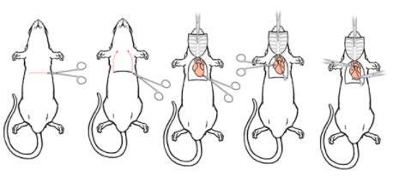
  - Use large flat tweezers to hold the heart gently while inserting a large gauge needle into the lower middle/right side of the heart (left ventricle); see below image
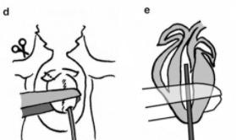
    - Don’t push too much of the needle inside the heart; can use tape on the needle tip if that helps!
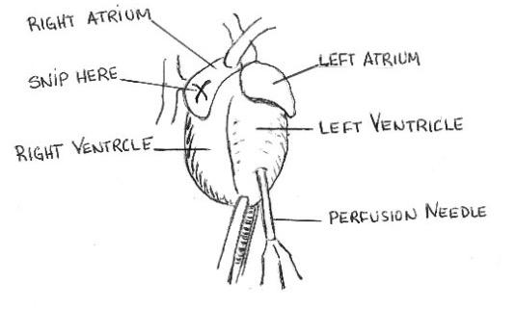
  - Use sharp scissors to cut into the right atrium; see “X” above in image.
  - Begin running the cold PBS via pump; liver should begin to clear over time
  - STOP pump; move over to PFA tube; START pump
    - Usually ~25mL
  - Body will begin to stiffen after a few minutes; the tail/legs may begin to move during fixation.
  - STOP pump; remove from PFA; START pump to make a little bubble in the line (avoid mixing PBS and PFA)
    - Run pump with fresh PBS before starting the next perfusion.
  - Brain extraction
    - Use large scissors to decapitate
    - Make a midline incision with sharp scissors from neck to eyes; pull skin back in both directions to expose the skull.
    - Use sharp scissors to remove excess muscle on back of skull
    - Cut along the backside of the skull from the brainstem up towards the middle of the skull--make sure to apply upward pressure so you don’t cut into the brain; slowly.
    - Make a cut between the eyes to release front of skull bone
    - Turn the skull horizontally; use grippy tweezers to pull off the two sides of the skull; again, with outward pressure to avoid damaging tissue.
    - Once the brain is exposed, use the spatula to gently move the brain into your conical tube filled with PFA; label tube. 