PS/NE 337 Memory Systems of the Brain
Spring 2019, in CAS226
Professor Steve Ramirez
Office: 610 Commonwealth Ave, Rm. 805A
e-mail: dvsteve@bu.edu
Office Hours: Monday 2-4pm or Wednesday 1-2pm, or send me an e-mail to arrange a time.
Teaching assistant: Hayley Fitzgerald
Office: 900 Commonwealth Avenue, 2nd floor (check in at the front desk of the Center for Anxiety and Related Disorders and Hayley will meet you in the waiting room).
e-mail: fhayley@bu.edu

Office hours: Wednesdays 11am-12pm and Thursdays 5pm-6pm
By appointment
Section Meeting time: Wed 12:20pm-1:10pm, Wed 1:25pm-2:15pm, Wed 2:30pm -3:20pm
As a general rule of mine, and space permitting, you may attend any section you wish.
Class Prerequisites: CAS PS/NE202, CAS PS231, CAS PS336, CAS BI325 or consent of instructor. Please read Class Preparation Section for more details regarding required background knowledge.
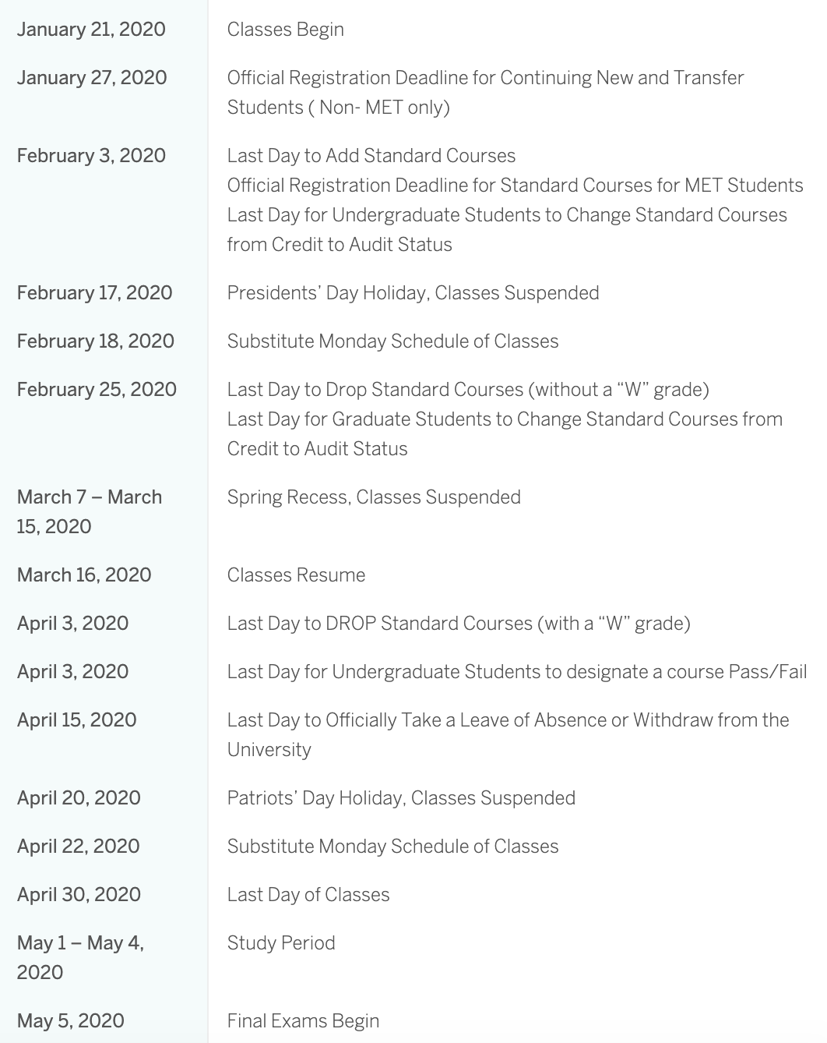
Course Description: Memories thread and unify our overall sense of being, as well as guide our decisions to interact with the world around us. This course aims to provide students with aa modern understanding of the nature and organization of memory at the systems neuroscience level. The course starts with an overview of the study of memory from a neuroscience perspective, and provides an introduction to the research techniques that are used to study memory systems in both humans and animals. Topics that are covered in this course include the anatomy of memory systems, animal and human models of memory, disorders that disrupt memory function such as Alzheimer’s Disease, false memories, artificially manipulating memories in rodents and humans, genetic inheritance of memories, and modern approaches (e.g. optogenetics, calcium imaging) used to study memory. Guest lectures by researchers and clinically trained individuals will provide students with the opportunity to hear from individuals who study memory by examining animal models, computational models, human neuropsychological and neuroimaging studies, and studies with patients with different memory disorders.
Course Materials. Required materials come from the following sources:
Original scientific papers and review papers will be listed weekly on the Blackboard website, as well as TED talks, YouTube clips, and supplemental movie clips. There are no problem sets, quizzes, or student presentations required.
Course Format and Requirements: The course format requires that students read the required readings or view the required media each week. The readings include both review articles and original papers. There is no textbook, but it is assumed that everyone has read at least one or two textbook chapters on memory in their prerequisite classes. During class, students are encouraged to ask questions about the lecture topic and the assigned reading material. I will normally lecture for about 45 minutes and then provide the remaining time for any questions or to present media to the class (e.g. TED talks, etc).
Students are required to attend classes and in keeping with BU policy attendance will be monitored at each class. I fully appreciate that unexpected events come up and therefore attendance won’t affect your overall grade directly, but I do expect you to be responsible for the material from missed classes (e.g. If you miss a class you are responsible for getting notes from a classmate). The instructor and TA provide class notes after each lecture. I will post all of my slides on the website before each class and also I will run a review sessions during the lecture before the scheduled exam. The TA will also run a review session during the scheduled discussion sections prior to the scheduled exam.
Students are required to abide by the CAS Academic Conduct Code. Cases of academic misconduct, including cheating on exams, will be reported to the Dean of CAS and the Chairman of the Department of Psychological and Brain Sciences and the Director of the Undergraduate Program in Neuroscience.
Grading criteria: There are no fixed percentages of A grades, B grades, C grades etc. I assign grades based on a curve. There will be 3 exams, each worth 33% of your grade. The third exam will be given during the final examination period. Each exam may contain a combination of multiple choice and fill in the blank questions. To aid in your preparation for exams, you will have the opportunity to take practice quizzes in section and I will post practice test questions at the end of each lecture. These quizzes will not be graded, but their purpose is to test your understanding of the material on a weekly basis and to provide you with an opportunity to see how I might structure an exam.
Suggestions for Class Preparation: You will get the most out of this class if you have read the assigned readings and bring the power point presentations to class. This will enable you to ask questions in class, follow the material as it is covered, and take part in the discussions. If you are not familiar with neuroanatomical terminology, one of the most important things to do is to get a good handle on the neuroanatomical terms and locations early in the course. This neuroanatomy should be a review from your prerequisite classes.
Suggestions for Assignments: The readings, clips, and required material are available on the course website. Questions to keep in mind as you are reading these papers are: What is the main question the authors are trying to address? What is their central hypothesis? What did the experiment set out to test? How was this accomplished? What were the results, and how did the authors interpret these results? Are alternative outcomes or hypotheses provided? What do the authors conclude, and are follow up studies suggested? If you have read other studies that are related, are the findings between the studies consistent, or is there still an open debate? Are there studies that might solve this debate? If the weekly reading assignment includes a review paper, then you should be able to summarize the most important questions being addressed, which questions have been addressed in the previous studies (and how) and what areas are logical areas for follow up experiments. Assignments also include video clips, audio clips, and movies about memory that students are encouraged to watch.
Note regarding course materials: The syllabus, course descriptions, and handouts created by Professor Ramirez, and all class lectures, are copyrighted by Boston University and/or Professor Ramirez. Except with respect to enrolled students as set forth below, the materials and lectures may not be reproduced in any form or otherwise copied, displayed or distributed, nor should works derived from them be reproduced, copied, displayed or distributed without the written permission of Professor Ramirez. Infringement of the copyright in these materials, including any sale or commercial use of notes, summaries, outlines or other reproductions of lectures, constitutes a violation of the copyright laws and is prohibited. Students enrolled in the course are allowed to share with other enrolled students course materials, notes, and other writings based on the course materials and lectures, but may not do so on a commercial basis or otherwise for payment of any kind. Please note in particular that selling or buying class notes, lecture notes or summaries, or similar materials both violates copyright and interferes with the academic mission of the College, and is therefore prohibited in this class and will be considered a violation of the student code of responsibility that is subject to academic sanctions.
EXAM DATES:
Feb. 27: EXAM #1 (Covers materials from Weeks 1-4)
April 2: EXAM #2 (Covers materials from Weeks 6-9)
April 30: FINAL (Covers materials from Weeks 1-13).
The final is cumulative, but split in 3 sections covering exam 1, exam 2, and the last third of the class. If did poorly on exam 1 or 2, or both, then I will take the average of your exam grade and the corresponding section on the final to determine your final grade.

DATES, TOPICS, READINGS, AND TALKS
WEEK 1 January 21 and 23
An overview of the class and introduction to memory systems
Anatomy and systems neuroscience of memory in rodents and humans
YouTube Clip: Joshua Foer
https://www.ted.com/talks/joshua_foer_feats_of_memory_anyone_can_do?language=en
Optional Reading: Larry Squire. Memory Systems of the brain: a brief history and current perspective
WEEK 2 January 28 and 30
Episodic memory: cortico-hippocampus circuits (cells types that process memory)
Episodic memory: cortico-hippocampus circuits (consolidation/reconsolidation, memory erasure)
YouTube Clip: Howard Eichenbaum: https://www.youtube.com/watch?v=0weuu7pf0zI
YouTube Clip: Daniela Schiller: https://www.youtube.com/watch?v=BnamYnZatjc
Movie: The Bourne Trilogy
Optional Reading: Howard Eichenbaum: What H.M. taught us
WEEK 3 February 4 and 6
Emotional memory: amygdala circuits (feelings and emotion; how to erase a memory)
Emotional memory: amygdala circuits (the neural basis of positive and negative emotions)
TED Talk: Alex Honnold https://www.youtube.com/watch?v=6iM6M_7wBMc
YouTube Clip: The Walk https://www.youtube.com/watch?v=hkAmU6N98mo
Movie: Eternal Sunshine of the Spotless Mind, Inside Out
Optional Readings:
http://blogs.discovermagazine.com/notrocketscience/2010/12/16/meet-the-woman-without-fear/#.XD4wVc9KjL8
http://nautil.us/issue/39/sport/the-strange-brain-of-the-worlds-greatest-solo-climber
WEEK 4 February 11 and 13
Guest Lecture by Hayley Fitzgerald: Human fear conditioning and exposure-based therapies
Motor Memory: Motor circuits (habit learning, brain-machine interfaces)
TED TALK: Daniel Wolpert
https://www.ted.com/talks/daniel_wolpert_the_real_reason_for_brains?language=enYouTube
Polina Anikeeva
https://www.ted.com/talks/daniel_wolpert_the_real_reason_for_brains?language=enYouTube
Optional: Miguel Nicolelis
https://www.ted.com/talks/miguel_nicolelis_brain_to_brain_communication_has_arrived_how_we_did_it
Clip: Reaction Time in Pitching: https://www.youtube.com/watch?v=FrZVRuK77EE
Movie: Concussion, Elysium
WEEK 5 February 18 and 20
NO CLASS (substitute Monday day of classes)
Working memory: prefrontal cortex (attention and consciousness)
WEEK 6 February 25 and 27
REVIEW for midterm 1
Midterm 1
TED Talk: Antonio Damasio
https://www.ted.com/talks/antonio_damasio_the_quest_to_understand_consciousness
Peter Doolittle
https://www.ted.com/talks/peter_doolittle_how_your_working_memory_makes_sense_of_the_world
Anil Seth
https://www.ted.com/talks/anil_seth_how_your_brain_hallucinates_your_conscious_reality?language=en
Reading: Earl Miller http://discovermagazine.com/2016/oct/your-attention-please
Optional: NPR: https://www.npr.org/sections/health-shots/2018/11/04/663668407/neuroscientists-debate-a-simple-question-how-does-the-brain-store-a-phone-number
Movie: Ex Machina
WEEK 7 March 3 and 5
Working memory: neocortical areas (attention and consciousness)
Neuromodulation of memory: dopamine, serotonin, and norepinephrine
TED TALK: David Anderson https://www.ted.com/talks/david_anderson_your_brain_is_more_than_a_bag_of_chemicals?language=en
TV Show: Breaking Bad, Narcos
Movie: Limitless
Optional Reading: Review. Maxwell Mehlman: Cognition-Enhancing Drugs
SPRING BREAK: March 10 and 12
WEEK 8 March 17 and 19
Psychiatric Disease and Memory: Depression, Anxiety, and PTSD
Psychiatric Disease and Memory: Depression, Anxiety, and PTSD
TED TALK: Johann Hari
https://www.ted.com/talks/johann_hari_everything_you_think_you_know_about_addiction_is_wrong?language=en
TED TALK: Tom Insel
https://www.ted.com/talks/thomas_insel_toward_a_new_understanding_of_mental_illness?language=en
Movie: Requiem for a Dream, Silver Lining’s Playbook, Iron Man 3
WEEK 9 March 24 and 26
Genetic basis of memories: zooming into neurons (receptors, potentiation, and DNA-RNA dynamics)
Genetic basis of memories: zooming into neurons (receptors, potentiation, and DNA-RNA dynamics)
TED TALK: Moshe Szyf
https://www.ted.com/talks/moshe_szyf_how_early_life_experience_is_written_into_dna?language=en
WEEK 10 March 31 and April 2
REVIEW
Midterm 2
WEEK 11 April 7 and 9
Manipulating memories: optogenetics and chemogenetics (artificially reactivating and deleting memories)
Imaging memories: histology and in vivo calcium imaging (tools to visualize the awake brain, anxiety cells, memory linking)
TED TALK: Shameful self-promotion https://www.ted.com/talks/steve_ramirez_and_xu_liu_a_mouse_a_laser_beam_a_manipulated_memory/discussion
Movie: Inception
WEEK 12 April 14 and 16
False memories: How to incept an idea (and its neural basis in rodents and humans)
False memories: How to incept an idea (and its neural basis in rodents and humans)
TED Talk: https://www.ted.com/talks/scott_fraser_the_problem_with_eyewitness_testimony
https://www.ted.com/talks/elizabeth_loftus_the_fiction_of_memory
YouTube Clip: Black Mirror (Crocodile, The Entire History of You); Making a Murderer
Movie: Blade Runner 2049
Required Reading: David Eagleman
https://www.theatlantic.com/magazine/archive/2011/07/the-brain-on-trial/308520/
WEEK 13 April 21 and 23
How to bring memories from out of Amnesia
Positive memories and sleep: ways to prevent memory impairments
TED TALK: Tomas Ryan
https://www.tedmed.com/talks/show?id=624548
Wendy Suzuki
https://www.ted.com/talks/wendy_suzuki_the_brain_changing_benefits_of_exercise
Russel Foster
https://www.ted.com/talks/russell_foster_why_do_we_sleep
Short Talk: https://www.ted.com/talks/diy_neuroscience_better_memory_while_you_sleep
Movie: Memento
WEEK 14 April 28 and 30
In-class review and a massive evening review, I’ll bring ALL the snacks #blessup
NO CLASS
TED TALK: https://www.ted.com/talks/daniel_kahneman_the_riddle_of_experience_vs_memory/discussion?referrer=playlist-the_complexity_of_memory
FINAL EXAM

